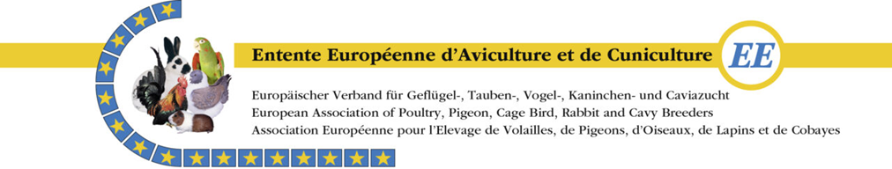
EE Breed Specific Cavy Show
Horsens, Denmark
October 5th 2024

Entry Form
Please note: After registration and payment you will receive a confirmation of your registration.
Surname :
Name :
Address :
Country :
Telephone no :
E-mail :
Juvenile : | Yes / no Date of birth :
Free sleep in dormitory : | No of persons:
A-class : 9 months or older, max 5 years

B-Class : 6-9 months

C-Class : 3 – 6 month and at least 500 gram
 | Amount per cavy | € 7,00 | €
1x | Catalouge | Digital | Free
1x | Administration fee | € 5,00 | € 5,00
 | Breeders Evening | € 40 / pers | €
 | Breeders Evening below 10 year | € 20 / pers | €
 | Sales cage(s) | € 3 / cage | €
 | Total |  | €

 | Breed | Colour / Variety | M / F | Class (A, B or C) | Collection* | Nett sales price
1
2
3
4
5
6
7
8
9
10
11
12
13
14
15
*Please number here when you want to have your collecction group to complete. For example all with Coll. 1 etc.
Entry closing & payment date : September 1st 2024
- Send entry form to EE-Horsens-2024@svenskamarsvinsforeningen.se
Payment to be sent to :
IBAN SE72 9500 0099 6018 2137 6058
BIC NDEASESS
Adress of bank: Nordea HQ, Smålandsgatan 15-17, SE-11 46 Stockholm, Sweden
OBS! If you pay from Sweden please use 213 76 05-8 for payment.

